**UNIVERSITY OF TOURISM, TECHNOLOGY AND BUSINESS STUDIES (UTB)**

**P.O.BOX:350 KIGALI**

**FACTULTY OF APPLIED SCIENCE AND TECHNOLOGY**

**DEPARTMENT OF BUSINESS INFORMATION TECHNOLOGY**

**Agricultural Ecommerce System with E-payment and E-fulfillment**

Case study: Cooperative Indatwa Kayonza

**Submitted by:**

**UWERA Chantal**

**Registration number:**

**Under the guidance and Supervisor of Dr. MBANZABUGABO Jean Baptiste**

**A Dissertation Submitted to Department of Business Information Technology in partial Fulfillment of the Requirements for the Award of the Bachelor’s Degree in Business Information Technology**

**April, 2021**

# Declaration

I declare that this research project report is my original work and it has never been submitted for any other academic award in any institution of higher learning.

Signature…………………………….. Date: ……………………

**UWERA Chantal**

# Approval

This report has been submitted for the examination with approval of the supervisor.

Signature ………………………………….. Date……………………….

**Dr. MBANZABUGABO Jean Baptiste**

# Acknowledgment

Success in life is never attained single handedly. It is on this note that, I express my heartfelt gratitude to God for the strength, wisdom and to various people who have assisted me in various ways to accomplish this project.

I also take great thanks to my parents for the great contribution towards my success.

My sincere appreciation goes to UTB Faculty of science and technology more especially so to my supervisor, for his guidance without whose help this work would not be as it appears. Lastly but not least, I acknowledge all my friends and classmates of the Information Technology program for having made my academic and social life comfortable at UTB.

May God bless you abundantly?

# Dedication

This work is dedicated to my beloved families which have made much offer in seeing us grow both academically and spiritually. May God uphold them to see the fruits from the child they have molded up to this academic level.

In a special way, I dedicate this project report to all those who gave us their support morally and financially.

Above all, I dedicate it to my supervisor who provided the necessary guidance during this project report.

# Abstract

*In this documentation the researcher aimed development of an Agricultural Ecommerce System with E-payment and E-fulfillment for CIK. This will provide the farmers and Customers electronic interactive market that will eliminate transport costs and other problems related to physical market. To achieve the above objective, the researcher aimed at the following specific objectives; To investigate and identify requirements that will lead to the development of Agricultural Products E-commerce System with E-payment and E-fulfillment System, To design and implement the new system as a way of solving the underlying problems faced by Agricultural products markets and to Test and validate the developed system to ensure proper functionality. Observation and Questionnaire methods were used to collect data from CIK. The researcher adopted prototype model for software development and used MS Excel for data analysis.*

*The new system comprises of a centralized MySQL database with a front end application Designed in PHP, JavaScript and HTML. The current system is a secured Agricultural Ecommerce System with E-payment And E-fulfillment System. This system aids CIK to know the trend of interaction between Famers and Buyers of agricultural produce. It helps the farmers to know that available markets for their produce and Interacting with potential buyers before meeting in physical market. The new system also helps the buyers of agricultural commodities to view detailed prices of given commodities before visiting physical markets.*

# List of Abbreviations

AESEE: Agricultural Ecommerce System with E-payment And E-fulfillment

CIK: Cooperative Indatwa Kayonza

SMS: Short Mobile Messages

DBMS: Database Management System

ERDs: Entity Relationship Diagrams

GUI: Graphical User Interface

IS: Information System

HTML: Hyper Text Markup Language

HTTP: Hyper Text Transfer Protocol

PHP: Hypertext Preprocessor

UTB: University of Tourism, Technology and Business studies

CSS: Cascading Styling Sheets

XAMPP: Cross-Apache, MySQL,PHP, Perl

Table of Contents

Declaration i

Approval ii

Acknowledgment iii

Dedication iv

Abstract v

List of Abbreviations vi

List of Figures x

List of Tables xi

CHAPTER ONE: GENERAL INTRODUCTION AND BACKGROUND TO THE STUDY 1

1.0 Introduction 1

1.1 Background to the study 1

1.2 Statement of the problem 3

1.3 Objectives of the study 4

1.3.1 Main goal of the study. 4

1.3.2 Specific goals of the study. 4

1.4 Research questions 4

1.5 Significance of the study 5

1.5.1 To the buyer 5

1.5.2 To the farmer 5

1.5.3 To the researcher 5

1.6 Scope of the study 5

1.6.1 Time Scope 5

1.6.2 Geographical Scope 5

1.6.3 Content Scope 6

1.7 Limitation 6

CHAPTER 2: LITERATURE REVIEW 7

2.0 Introduction 7

2.1 Definition of key concepts 7

2.2 Related Literature 8

2.2.1 Requirements that will lead to the development of Agricultural Products E-commerce System with E-payment and E-fulfillment System. 8

2.2.2 Design and implement methodologies of the new system as a way of solving the underlying problems faced by Agricultural products markets. 9

2.2.3 Tests and validate methods used in developing system to ensure proper functionality. 10

2.3 Related Projects 13

2.4 Summary 14

CHAPTER 3: RESEARCH METHODOLOGY 15

3.0 Introduction 15

3.1 Research design 15

3.2 Population and selection of the sample 15

3.3 Tools for data collection 15

3.3.1 Questionnaire 15

3.3.2 Observation Checklist 15

3.4 Collection of data 16

3.4.1 Questionnaire method 16

3.4.2 Observation method 16

3.5 Analysis of data 16

3.6 Validity and Reliability 16

3.7 Ethical Considerations 16

CHAPTER FOUR: SYSTEM ANALYSIS AND DESIGN 18

4.1 Introduction 18

4.2 Data analysis and presentation 18

4.2.1. Description of the study respondents 18

4.2.2 Data gathered from all Respondents 19

4.3 Interpretation of findings 22

4.4 Summary 23

4.5. Software development model 23

4.7 Description of the new system 25

4.8 Illustration of New system 26

4.8.1 Data Flow Diagram 26

4.8.2 Use Case 28

4.8.3 Normalization 30

4.8.4 Data Dictionary 36

4.8.5 Entity Relationship Diagram 37

4.9 Architecture design of the new System 38

CHAPTER FIVE: IMPLEMENTATION, CODING AND TESTING 40

5.1 Implementation and coding 40

5.1.1 Introduction 40

5.1.2 Description of implementation Tools and technology 40

5.1.3Screen Shots and Source Codes 41

5.2 System Testing 53

5.2.1 White Box Testing 54

5.2.2 Black box Testing 54

5.3 Recommendations 55

5.4 Conclusion 55

Appendix A: References 56

# List of Figures

Figure 4. 1: Prototype model 25

Figure 4.2: Level 0 - Data flow Diagram 27

Figure 4.3: Level 1 - Data flow Diagram 27

Figure 4.4: Level 2 - Data flow Diagram 28

Figure 4.5: Use Case Diagram 29

Figure 4.6: Normalization 30

Figure 4.7: Entity Relationship Diagram 37

Figure 4.8: Three Tier Architecture 39

Figure 5.1: Home Page 42

Figure 5.2: Login Page 46

Figure 5.3: Administrator’s Page 49

Figure 5.4: Farmers Page 52

# List of Tables

Table 4.1: Gender Respondents 19

Table 4.2: Age of Respondents 19

Table 4.3: Educational Level of Respondents 20

Table 4.4: Working Experience 21

Table 4.5: Computerized System Use 22

Table 4.6: How to Inter Communicate 22

Table 4.7: 1st Normal Form A 31

Table 4.8: 1st Normal Form B 31

Table 4.9: 2nd Normal Form A 32

Table 4.10: 2nd Normal Form B 32

Table 4.11: 2nd Normal Form C 33

Table 4.12: 3rd Normal Form A 34

Table 4.13: 3rd Normal Form B 35

Table 4.14: 3rd Normal Form C 35

Table 4.15: farmer table 35

Table 4.16: customer table 36

Table 4.17: admin table 36

# CHAPTER ONE: GENERAL INTRODUCTION AND BACKGROUND TO THE STUDY

# 1.0 Introduction

E-commerce is clearly beginning to have a major impact in the agricultural sector. The way people go about purchasing agricultural products is of great concern. Most of the time Customers have to travel far distances to get agricultural products and getting the right quality is not ensured. Besides, farming is the prime occupation in Rwanda. Rwandans involved in farming are mostly cheated by the agents in today’s market which leads to poverty. Our project aims to help farmers as well as Customers for buying and selling agricultural products across the country using a computerized approach. The website will guide the farmers to access new farming techniques, compare current market rate of different products, the total sale and the earned profit for the sold products. The website builds a platform for farmers and agents to ensure greater profitability through direct farmer to farmer, farmer to agent and farmer to customer communication. The website will act as a unique and secure way to perform agro-marketing. E-farming will serve as a way for the farmers to sell their products across the country just with some basic knowledge about how to use the website. This project allows viewing various products available enables users to purchase desire products instantly by online payment. This website would be developed using web service as the communication infrastructure between the buyer and farmers and also products selling.

# 1.1 Background to the study

According to N. Walsh(1999), Worldwide, E-commerce is fast gaining ground as an accepted and used business paradigm. More and more agricultural sectors are implementing web sites providing functionality for performing commercial transactions over the web. It is reasonable to say that the process of shopping on the web is becoming common place. It is the buying and selling of goods and services, or the transmitting of funds or data, over an electronic network, primarily the internet.

According to Robinson and M. McDonald (1994), Ecommerce business transactions occur either as business-to-business, business-to-consumer, consumer-to-consumer or consumer-to-business. The terms e-commerce and e-business are often used interchangeably.

According to W. Bile (2000), Agricultural E-commerce enables good trading possibilities by supporting different business models such as multi-suppliers, e-sales and several types of auctions. It can blur the physical existence of agro-allied stores, the integrity of products is ensured no paper money involved in the process, distance doesn’t exist and so on. Today E-commerce lacks fully automated business processes and still requires a significant manual effort by users. So our project tries to solve all lacking of E-commerce business process.

According to B. Mails (2009) With variation on the mix of the ingredients (use of technologies and communication media; structure and design components for information collection, analysis, and dissemination; markets and content coverage; types of users), marketing information systems used by different organizations are invariably different. Based on the purpose of the system and organization managing it, the agriculture MIS can be broadly grouped under- a) MIS supported by development projects, b) MIS managed by government, c) MIS services managed by member based organizations or service providers, and d) MIS of agriculture enterprise. Each category has its own strengths and weaknesses.

According to M. Bile (2000), MIS supported by development organization is often targeted to farmer communities and finds difficulty to sustain, when not integrated to the appropriate existing institutional system, after the project support is over. The Nepal non-timber forest products (NTFP) marketing information system, developed through multi-stakeholders’ interactions and managed by ANSAB, provides marketing information on various non-timber forest products to collectors, local traders and entrepreneurs, and development facilitators through a network of organizations. The district MIS managed by the Ilam Chamber of Commerce provides trade related information on selected cash crops to their members and farmer communities. MIS managed by the Agro Enterprise Center, an arm of Federation of Nepalese Chamber of Commerce and Industries, provides trade information on selected agriculture crops through website, email, and fax to their members, and some information also to other interested organizations. The Rural Urban Partnership Programme of UNDP supports municipalities to develop a comprehensive information system including MIS on agriculture crops to build their capacity on planning and development of their area. It also supports Agro Enterprise Center to extend the scope of their MIS and introduce e-commerce services.

According to L. Franline (2004), He criticized Agricultural Information Systems arguing that, besides funding, there are other challenges, too. Marketing information systems face criticisms for failing to continuously provide value adding information, reach out to grassroots communities, deliver the information timely in the remote locations, and provide more analytical and accurate information in a way that the target groups understand. When information, such as prevalent prices in different markets, is provided to remote poor farmers, it is sometimes opposed by some traders who can otherwise benefit from blocking the information. Nevertheless, while designing a marketing information system, one always has to weigh the costs and benefits, and has to make difficult decisions on what contents to include, what markets to cover, what products to prioritize, how often to collect and disseminate the information, what level of market analysis to executive; and most importantly whom to target and how to timely reach the target groups with useful information to them.

The main objective of this project is to help farmers ensure greater profitability through direct farmer to farmer, farmer to customer & farmer to dealer communication. Our project deals with respect to the farmer’s benefit of getting their products sale at a best price online. Here, the main users of this website are farmer, customer and admin. Farmers will get unique interface where they can perform marketing, get the correct rates of the market, get in touch with potential Customers through SMS or Email and gather knowledge of different schemes and transact payments using mobile money. It will provide market wise, commodity wise report to the farmer in interactive way. The centralized market committee will control all business activities.

# 1.2 Statement of the problem

According to MINAGRI report (2018), Rwanda is agricultural country. Majority of Rwanda people live on agricultural. So, Agricultural institutes, research bases agencies and other resources related to agriculture in Rwanda is vitally important. Nowadays, the farmers have to go to the nearest market to hand over his product to a particular agent where agent sells the product to another agent or a dealer. After a specific time the agent gives the collected cash out of the sold products to the respected farmer but every Agent tries to cuts his commission out of the earned amount. The whole process is not transparent as there is no way for farmer to know about the deal and the exact amount at which their product was sold. No facility is present for the farmers to know the product rates at different markets where they can sell their products for achieving high profits. Our project aims to help farmers to sell their products in a transparent way.

# 1.3 Objectives of the study

## 1.3.1 Main goal of the study.

To develop an Agricultural Products E-commerce System with E-payment and E-fulfillment System that will help farmers to smoothly interact with potential Customers.

## 1.3.2 Specific goals of the study.

The following are specific objectives of Agricultural Products E-commerce System with E-payment and E-fulfillment System

(i) To investigate and identify requirements that will lead to the development of Agricultural Products E-commerce System with E-payment and E-fulfillment System.

(ii) To design and implement the new system as a way of solving the underlying problems faced by Agricultural products markets

(iii) Test and validate the developed system to ensure proper functionality.

# 1.4 Research questions

(i) What are the requirements that will lead to the development of Agricultural Products E-commerce System with E-payment and E-fulfillment System?

(ii) What is the suitable design and implement methodologies of the new system as a way of solving the underlying problems faced by Agricultural products markets?

(iii) What are the Tests and validate methods used in developing system to ensure proper functionality.

# 1.5 Significance of the study

## 1.5.1 To the buyer

1. The system will eliminate transport costs to the market place since the buyer will check for the availability of the agricultural product online, makes orders and payments then the goods are delivered to his home.
2. Buyers will not be cheated since prices will be fixed and no bargaining power will beat the buyers like previous physical markets.

## 1.5.2 To the farmer

1. The system will allow sellers to fix prices, hence minimizing time of haggling with Customers and being out won by smart buyers during the entire process of price bargaining.
2. The system will generate sales and order reports without any human calculation in a shortest possible time.

## 1.5.3 To the researcher

1. After completion of the research process the researcher will have gained knowledge about data collection and other research activities.
2. The researcher will also gain knowledge on how web applications are designed and developed and even incorporated with mobile SMS APIs.

# 1.6 Scope of the study

## 1.6.1 Time Scope

The research process will take duration of 3 years. It was started from 2017 up to, 2020.

## 1.6.2 Geographical Scope

The study will be conducted in Cooperative Indatwa Kayonza in Kayonza District, Eastern Provence in Rwanda.

## 1.6.3 Content Scope

The research will base on all activities ranging from uploading agricultural products description and prices, ordering for products, mobile money payments and capturing of Customers address.

# 1.7 Limitation

1. CIK being a national organization with high profile data, the researcher was not availed all the necessary information to develop the system.
2. Time will be too limited for carrying out all the research activities about general buying and selling process.
3. The researcher resides a distance from CIK head office at Kayonza therefore the researcher will face transport costs to visit the case study and deliver her work to the school supervisor.
4. Lastly, agricultural products Customers are scattered therefore it became harder for the researcher to identify and get the potential Customers with ease.

# CHAPTER 2: LITERATURE REVIEW

# 2.0 Introduction

In this chapter 2, I will define common terms used in Agricultural Products E-commerce System with E-payment and E-fulfillment Process; illustrate how the system and the entire research will be carryout basing on the objectives stated in Chapter I and how other scholars developed related systems.

# 2.1 Definition of key concepts

Agriculture: According to F. Kellington (1995), agriculture is the art and science of cultivating the soil, growing crops and raising livestock. It includes the preparation of plant and animal products for people to use and their distribution to markets.

E-Commerce: According to Bill Clinch (2003), Ecommerce, also known as electronic commerce or internet commerce, refers to the buying and selling of goods or services using the internet, and the transfer of money and data to execute these transactions.

E-Payment: An electronic payment (e-payment), in short, can be simply defined as paying for goods or services on the internet. It includes all financial operations using electronic devices, such as computers, smart phones or tablets. E-payments come with various methods, like credit or debit card payments or bank transfers, (M.Collins 2013).

E-Fullfillment: According to J. White (2017), he define E-fulfilment as “the arrangements that are necessary for businesses to sell their products or services on the internet.” Many businesses take the hassle out of these “arrangements” by outsourcing them to a e-fulfilment service like James and James.

Agricultural products: According to McAllister (1989), Agricultural products means crops, livestock and livestock products, including but not limited to field crops, fruits, vegetables, horticultural specialties, cattle, sheep, hogs, goats, horses, poultry, furbearing animals, milk, eggs and furs.

Management System: It is the framework of policies, processes and procedures used by an organization to ensure that it can fulfill all the tasks required to achieve its objectives.

# 2.2 Related Literature

## 2.2.1 Requirements that will lead to the development of Agricultural Products E-commerce System with E-payment and E-fulfillment System.

According to Alicia Conrad (2000), to get an idea on requirements and components of a good Agricultural Products Market, study some online stores that are consistently ranked among the best, such as Amazon (pretty much everything), Schwans (food), Drs. Foster and Smith (pet supplies), or Land’s End (catalog/clothing).

Only then are you ready to start building your store. It will share a few standard components with others, such as

1. Product catalog: The catalog component organizes your inventory and presents products consistently. Unless you have only a few products, you generally enter your product list into a database or spreadsheet that includes at least the product name, category, description, price, and photo filename.
2. Shopping cart: Users place their tentative purchases into a cart, which tracks the contents, allows shoppers to delete items or change quantities, and provides a subtotal of the amount due. If you have a small store with only a few items, you can use an online order form rather than a cart. Be sure that your developer programs the form to handle arithmetic automatically. Too many people can’t double a price or add a column of numbers.
3. Check stand: This portion of your online store computes shipping and taxes, totals the bill, and accepts shipping and billing information (including credit card numbers) in a secure manner. The check stand or other element of the storefront should issue an onscreen *Thank You* to confirm order submission and e-mail an order confirmation.
4. Reporting and order tracking: Unless your store is very small, it helps to have easy-to-understand reports on sales, Customers, and product popularity. The larger your store, the more store analytics you want. Order tracking allows you, and your customer, to know the status of an order in terms of fulfillment and shipping.
5. Other add-ons: Large, sophisticated stores might interface with inventory, point-of-sale, and accounting systems. They might also integrate with live sales interaction capability, customer relationship management (CRM) systems that track a customer’s experience with your business, or other enterprise-level solutions. Online shoppers buy convenience and time, not just products.

* Product: The products that sell well online are not necessarily the same as the ones that sell well offline.
* Price: You don’t have to price products the same in online and offline environments unless your online audience is likely to come into the store to purchase. Your competition, overhead, cost of sales, and cost of shipping might differ between online and offline stores, just as they might between stores in different physical locations. If you decide to keep prices the same, you might need to adjust the price in both channels to maintain your profit margin.
* Placement: The placement of items on a page determines how much attention they receive and, therefore, how well they sell. Think of your site as containing multiple internal distribution channels.
* Promotion: You can use onsite promotion, such as internal banners, discounts, up sales, and other techniques to move products and increase sales.

## 2.2.2 Design and implement methodologies of the new system as a way of solving the underlying problems faced by Agricultural products markets.

According to (Mt Keten burgh 1982), Software systems are an integral part of our lives these days. They form the basis of our cell phones, tablets, and laptops. They contribute to our televisions, alarms clocks, and automobiles. And they even power the website you're using to work through this lesson. What's even more amazing is that a group of software engineers can put their heads together and design such systems. As you might imagine, this is no easy task, especially when you consider their complexity. So, how do they do it? How do they handle such difficult tasks? One way is to employ a design model representation.

According to Tom Hills (2009), a design model in Software Engineering is an object-based picture or pictures that represent the use cases for a system. Or to put it another way, it is the means to describe a system's implementation and source code in a diagrammatic fashion. This type of representation has a couple of advantages. First, it is a simpler representation than words alone. Second, a group of people can look at these simple diagrams and quickly get the general idea behind a system. In the end, it boils down to the old adage, 'a picture is worth a thousand words.'

## 2.2.3 Tests and validate methods used in developing system to ensure proper functionality.

According to Amnex R. Canon (1989), there are generally four recognized levels of testing: unit/component testing, integration tests, system testing, and acceptance testing. Tests are frequently grouped by where they are added in the software development process, or by the level of specificity of the test. Below you can see 4 different levels of testing.

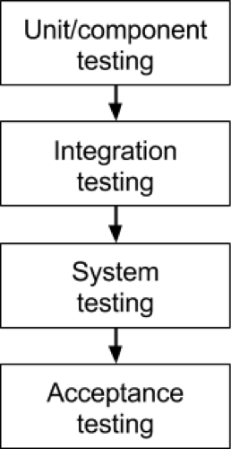

**Figure 2.2: Levels of System Test**

**Unit/component testing**

The most basic type of testing is unit, or component, testing. Unit testing aims to verify each part of the software by isolating it and then perform tests to demonstrate that each individual component is correct in terms of fulfilling requirements and the desired functionality. This type of testing is performed at the earliest stages of the development process, and in many cases it is executed by the developers themselves before handing the software over to the testing team.

The advantage of detecting any errors in the software early in the day is that by doing so the team minimizes software development risks, as well as time and money wasted in having to go back and undo fundamental problems in the program once it is nearly completed.

**Integration testing**

Integration testing aims to test different parts of the system in combination in order to assess if they work correctly together. By testing the units in groups, any faults in the way they interact together can be identified. There are many ways to test how different components of the system function at their interface; testers can adopt either a bottom-up or a top-down integration method.

In bottom-up integration testing, testing builds on the results of unit testing by testing higher-level combination of units (called modules) in successively more complex scenarios.

It is recommended that testers start with this approach first, before applying the top-down approach which tests higher-level modules first and studies simpler ones later.

**System testing**

The next level of testing is system testing. As the name implies, all the components of the software are tested as a whole in order to ensure that the overall product meets the requirements specified. System testing is a very important step as the software is almost ready to ship and it can be tested in an environment which is very close to that which the user will experience once it is deployed. System testing enables testers to ensure that the product meets business requirements, as well as determine that it runs smoothly within its operating environment. This type of testing is typically performed by a specialized testing team.

**Acceptance testing**

Finally, acceptance testing is the level in the software testing process where a product is given the green light or not. The aim of this type of testing is to evaluate whether the system complies with the end-user requirements and if it is ready for deployment.

The testing team will utilize a variety of methods, such as pre-written scenarios and test cases to test the software and use the results obtained from these tools to find ways in which the system can be improved. The scope of acceptance testing ranges from simply finding spelling mistakes and cosmetic errors, to uncovering bugs that could cause a major error in the application. By performing acceptance tests, the testing team can find out how the product will perform when it is installed on the user’s system. There are also various legal and contractual reasons why acceptance testing has to be carried out.

**The testing sequence**

These four testing types cannot be applied haphazardly during development. There is a logical sequence that should be adhered to in order to minimize the risk of bugs cropping up just before the launch date. Any testing team should know that testing is important at every phase of the development cycle. By progressively testing the simpler components of the system and moving on the bigger, more complex groupings, the testers can rest assured they are thoroughly examining the software in the most efficient way possible.

The four levels of testing shouldn’t only be seen as a hierarchy that extends from simple to complex, but also as a sequence that spans the whole development process from the early to the later stages. Note however that later does not imply that acceptance testing is done only after say 6 months of development work. In a more agile approach, acceptance testing can be carried out as often as every 2-3 weeks, as a part of the sprint demo. In an organization working more traditionally it is quite typical to have 3-4 releases per year, each following the cycle described here.

Lastly, testing early and testing frequently is well worth the effort. By adopting an attitude of constant alertness and scrutiny in all your projects, as well as a systematic approach to testing, the tester can pinpoint any faults in the system sooner, which translates in less time and money wasted later on. Detecting software errors early is important since it more effort is needed to fix bugs when the system is nearing launch, and — due to the interactive nature of components in the system — one small bug in a particular component hidden deep within layers of code can result in an effect that is magnified several times over on a system-level.

# 2.3 Related Projects

BADC (Bangladesh Agricultural Development Corporation) provides quality agricultural inputs supply, efficient irrigation management and production of high yielding seeds of different crops. It also provides the best use of surface water, irrigation efficiency by reducing logging and increasing irrigated areas and farmers to supply quality fertilizer, (C. Poells 2017).

BARC (The Bangladesh Agricultural Research Council) is to develop an efficient, effective and sustainable system of agricultural research promoting to increase standard of living, which would be adequate for well-being of the people of Bangladesh ,(M. Phillips 2014). BARC also is to strengthen and mobilize research capabilities of the institutes of the NARS, universities, private sectors and other stakeholders in partnership in the generation of appropriate technologies and information for the development of agriculture sector.

BARI (Bangladesh Agricultural Research Institute) is an autonomous organization under the Ministry of agriculture, that conducts research on all crops except rice, jute, sugarcane, and tea for which there are separate institutes. The central research station of the institute is at Joydebpur about 35 kilometers (22mi) north of Dhaka. The research compound of the central station is spread over 176 hectares of land of which 126 hectares are experiment fields (MK. Henning, 2016).

MOA (Ministry of Agriculture) is one of best ministries of the Government of the People's Republic of Bangladesh. It comprises seven wings with responsibilities of policy formulation, planning, monitoring and administration. Sixteen agencies operate under this ministry which is responsible for implementation of different projects and plans of MOA. MOA develops agricultural policies, plans, regulations, acts and provide support in developing new agricultural technologies to boost up agricultural production and coordinate with local and international trade agencies for marketing, (Max Wildlings, 2013).

# 2.4 Summary

Agricultural Products market software developed for CIK has been designed to achieve maximum efficiency and reduce the time taken to manage interaction between Agro-producers and Customers. It is designed to replace an existing manual record system thereby reducing time taken for calculations and for storing data. The system uses HTML, JavaScript and CSS as front end and Microsoft SQL as a backend for the database. The system is strong enough to withstand regressive daily operations under conditions where the database is maintained and cleared over a certain time of span. The implementation of the system in the organization will consider reduced data entry, time and also provide readily calculated reports.

# CHAPTER 3: RESEARCH METHODOLOGY

# 3.0 Introduction

Research methodologies refer to the way used to systematically solve the research problem. It is a science of studying how research is done scientifically. (Kothari, 1990). This chapter covers Research design, Population and selection of the sample, data collection Instrumentation, Collection of data, Analysis of data, Validity and Reliability, Ethical Considerations

# 3.1 Research design

The researcher will use quantitative research design. This will involve statistical data about all activities involved during Agricultural Products E-commerce. This is because this design will provide accurate conclusions of facts which will be useful during entire research process.

# 3.2 Population and selection of the sample

The target population will be both the CIK farmers and the final consumers. CIK being a Cooperative society with many farmers, only 15 CIK Farmers, 15 consumers were selected as respondents. Hence the researcher will use a sample size of 30 respondents.

# 3.3 Tools for data collection

## 3.3.1 Questionnaire

The researcher will design a list of short answer questions like multiple choice questions to be given to respondents at the case study. This will be done because all the respondents are always busy in field work, let them be CIK Customers, CIK Farmers.

## 3.3.2 Observation Checklist

During the researchers visit to the case study, he will develop a checklist of required subjects to research about. As she physically observes interaction between all the three entities in question, she will be able to pin point important information that will be used during the research process.

# 3.4 Collection of data

## 3.4.1 Questionnaire method

During data collection, the researcher will provide the questionnaires to the respondents. This method will be used due to its simplicity in data analysis and reliable for the respondents since they will be provided with choices to select from. Each respondent will be given his questionnaire and will not include his name for the sake of his privacy and security.

## 3.4.2 Observation method

Since the researcher will visit the case study and observe how the current shop operates, she will write short notice about what she will have observed that can help her in the research process. The documented list of summarized observations is called the observation checklist. The checklist is summarized and directed to the main objective of the research.

# 3.5 Analysis of data

Data analysis will involve sorting and deriving of use full data from all the data collected using data collection methods above by the researcher from the case study. Common data analysis software called Microsoft office Excel will be used to get statistical data from the data collection tools. This will be used because it is a free package of Microsoft office and is commonly used within the reach of the researcher.

# 3.6 Validity and Reliability

Valid research instruments will be employed ranging from data collections method and tools, data analysis tools. This will ensure reliability of data collected for better research results. This is because a valid research instrument is always a reliable one.

# 3.7 Ethical Considerations

Information content that contains data that can lead to exposure of CIK and farmers confidential reports will be excluded from the research questionnaires and other data collection tools.

Voluntary participation in data collection at the case study will be emphasized. Respondents will not be forced to provide research data. This will prevent biased data from unwilling respondents at the case study. This data can mislead the researcher.

Privacy of respondents will be maintained by not exposing their consumption habits. Debts and credit files will be accessed with the highest level of privacy through consulting only sales persons responsible for such shop rockers.

Confidentiality of the organizations; data will be emphasized by not exposing CIK information to third party. The computer holding such classified information will be secured and only accessed by the researcher.

# CHAPTER FOUR: SYSTEM ANALYSIS AND DESIGN

# 4.1 Introduction

This Chapter will comprise of system data analysis, presentation and interpretation of data and the design view of the new system.

# 4.2 Data analysis and presentation

Data analysis is a logical process; the objective of this phase is not actually to solve the problem but to determine what must be done to solve the problem. The basic objective of the analysis stage was to develop the logical model of the system using tools such as the data flow diagram and elementary data description of the elementary algorithm. The logical model was subjected to revision by the RA farmers, Customers and the researcher who agreed that the model in fact reflected what should be done to solve the problem.

### 4.2.1. Description of the study respondents

The study was conducted in Cooperative Indatwa Kayonza found in Kayonza District in Eastern Rwanda. The findings were guided by the selected instruments for this study which are observation and questionnaires.

CIK has Employees who offer services to farmers in form of training, selling them their produce. The farmers in the end sale their agricultural products directly to Customers or Customers organized in cooperative societies. Below are respondents that were selected from the target population.

- CIK Customers. The researcher selected 10 CIK Customers at the case study with whom the questionnaires were given to provide research data.

- Farmers. The researcher selected 10 Farmers who get services from CIK with whom the questionnaires were given to provide research data.

- CIK Customers. The researcher selected 10 Customers with departmental stores who buy produce from model farmers with whom the questionnaires were given to provide research data.

### 4.2.2 Data gathered from all Respondents

*Table1. Gender of respondents*

|  |  |  |  |  |  |
| --- | --- | --- | --- | --- | --- |
| **CIK Farmers** | | | **CIK Customers** | | |
| **Gender** | **Respondents** | **Percentage** | **Gender** | **Respondents** | **Percentage** |
| M | 07 | 46% | M | 07 | 46% |
| F | 08 | 55% | F | 08 | 55% |
| Total | 15 | 100% |  | 15 | 100% |

Compiled by researcher, 2021

Table 4.1: Gender Respondents

The above table shows that all genders were equally represented during research since almost 50% on all respondent types were either Males or Females.

*Table 2 Age of respondents*

|  |  |  |  |  |  |
| --- | --- | --- | --- | --- | --- |
| **CIK Farmers** | | | **CIK Customers** | | |
| Age | Respondents | Percent | Age | Respondents | Percent |
| < 20Years | 00 | 00% | < 20 | 00 | 00% |
| 21-30Years | 03 | 20% | 21-30 | 03 | 20% |
| 31-40Years | 10 | 67% | 31-40 | 10 | 67% |
| > 50 years | 02 | 13% | > 50 | 02 | 13% |
| **Total** | **15** | **100%** |  | **15** | **100%** |

Compiled by researcher, 2021

Table 4.2: Age of Respondents

The above table shows that the majority of the respondents are in the age of 21-30, and 31-40 years which indicates that they are mature in what they do hence they can work well.

*Table 3 Respondent's educational level*

|  |  |  |  |  |  |
| --- | --- | --- | --- | --- | --- |
| **CIK Farmers** | | | **CIK Customers** | | |
| **Level** | **Respondents** | **Percent** | **Level** | **Respondents** | **Percent** |
| Primary | 00 | 00% | Primary | 03 | 20 |
| A2 | 00 | 00% | A2 | 10 | 67 |
| A1 | 00 | 00% | A1 | 02 | 13 |
| A0 | 15 | 100% | A0 | 00 | 00 |
| **Total** | **15** | **100%** |  | **15** | **100** |

Compiled by researcher, 2021

Table 4.3: Educational Level of Respondents

This table shows all respondents have an academic level of education. This indicates that their level of literacy allows them to use the system.

*Tables 4.How long have you been in Agriculture Sector?*

|  |  |  |  |  |  |
| --- | --- | --- | --- | --- | --- |
| **CIK Farmers** | | | **CIK Customers** | | |
| **Year** | **Respondents** | **Percent** | **Year** | **Respondents** | **Percent** |
| 1 year | 00 | 00% | 1 year | 00 | 00% |
| 1-2 years | 00 | 00% | 1-2 years | 00 | 00% |
| 2-3 years | 05 | 30% | 2-3 years | 00 | 00% |
| > 3 years | 10 | 70% | > 3 years | 15 | 100% |
| **Total** | **15** | **100%** | **Total** | **15** | **100%** |

Compiled by researcher, 2021

Table 4.4: Working Experience

Table above shows that 100% of respondents have spent more than 2 Years in agriculture sector. Therefore, the information collected from them may be more reliable due to their experience.

*Table 5. Do you have a computerized system in Agriculture Sector?*

|  |  |  |  |  |  |
| --- | --- | --- | --- | --- | --- |
| **CIK Farmers** | | | **CIK Customers** | | |
|  | **Respondents** | **Percent** |  | **Respondents** | **Percent** |
| Yes | 00 | 00% | Yes | 00 | 00% |
| No | 15 | 100% | No | 15 | 100% |
| Total | 15 | 100% | Total | 15 | 100% |

Compiled by researcher, 2021

Table 4.5: Computerized System Use

This one shows that there is no availability of a computerized system for Agricultural Sector in Rwanda and specifically in Cooperative Indatwa Kayonza in Kayonza District.

*Table 6.How does the agricultural Sector Inter Communicate?*

|  |  |  |  |  |  |
| --- | --- | --- | --- | --- | --- |
| **CIK Employee** | | | **Famers** | | |
| **Means** | **Respondents** | **Percent** | **Means** | **Respondents** | **Percent** |
| **Phone** | 03 | 20% | **Phone** | 03 | 20% |
| **Face- to- Face** | 12 | 80% | **Face- to- Face** | 12 | 80% |
| **Total** | **15** | **100%** | **Total** | **15** | **100%** |

Compiled by researcher, 2021

Table 4.6: How to Inter Communicate

Table 6 shows that Tenants are contacted using both Telephone and face to face contact. Therefore there is a need for electronic means of interaction.

# 4.3 Interpretation of findings

According to M. McCoy (1998), interpretation is the process of making sense of numerical data that has been collected, analyzed, and presented. Questionnaires were used to correct data from respondents. After words, data was the tallied into MS EXCEL sheets for processing. This Numerical was analyzed using data analysis software like MS EXCEL in tables. Data collected from different respondents were compared to establish the most occurring responses. They were then used in the presentation of findings. Data from questionnaires were handled properly categorized and edited for accuracy and completeness of the uniformity.

# 4.4 Summary

Agricultural Ecommerce System with E-payment And E-fulfillment System designed for the CIK has been aimed at achieving maximum efficiency in aiding inter communication between CIK, Famers and Customers to smoothen buying and selling of agricultural produce. It is designed to replace an existing manual system of buying and selling agricultural produce. The system uses HTML, JavaScript and CSS as front end and Microsoft SQL as a backend for the database. The system is strong enough to withstand regressive daily operations under conditions where the database is maintained and cleared over a certain time of span. The implementation of the system in the organization will considerably reduce data entry, time and also provide readily calculated reports.

# 4.5. Software development model

The development models are the various processes or methodologies that are being selected for the development of the project depending on the project’s aims and goals. There are many development life cycle models that have been developed in order to achieve different required objectives. The models specify the various stages of the process and the order in which they are carried out.

The selection of model has very high impact on the testing that is carried out. It will define the what, where and when of our planned testing, influence regression testing and largely determines which test techniques to use. There are various Software development models or methodologies. They are as follows: Prototype model, Waterfall model, V model, Incremental model, RAD model (Rapid application development), agile model, Iterative model and Spiral model.

Among all of above software development models the researcher chose to use the Prototype model. This process is in contrast with the 1960s and 1970s monolithic development cycle of building the entire program first and then working out any inconsistencies between design and implementation, which led to higher software costs and poor estimates of time and cost.

**Advantages of Prototype model**

* The first and foremost advantage of prototyping it helps the developer to understand the certain and uncertain requirements of the customer.
* It helps the customer to easily realize the required modification before final implementation of the system.
* The efforts required in developing the final system is reduced as the final system is implemented after all the specifications are clearly understood and there are fewer chances of final system being incorrect.
* The customer does not have to wait for a long to see the working model of the final system.
* There are more chances of the developed system is more user-friendly.
* User satisfaction is achieved.

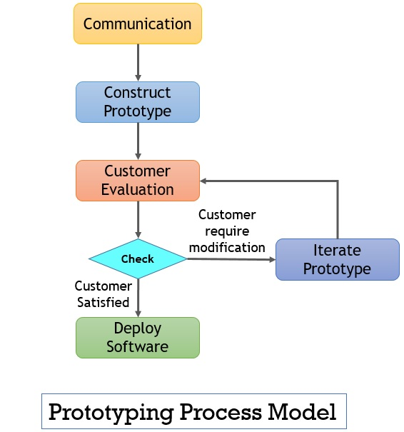

Figure 4. 1: Prototype model

**Source:** [*https://binaryterms.com/prototyping-model.html*](https://binaryterms.com/prototyping-model.html) retrieved on February, 2021

# 4.7 Description of the new system

The new system comprises of a centralized MySQL database with a front end application Designed in PHP, JavaScript and HTML. The current system is a secured Agricultural Ecommerce System with E-payment And E-fulfillment System. This system aids CIK to know the trend of interaction between its Famers and Buyers of agricultural produce. It helps the farmers to know that available markets for their produce and Interacting with potential buyers before meeting in physical market. The new system also helps the buyers of agricultural commodities to view detailed prices of given commodities before visiting physical markets.

# 4.8 Illustration of New system

## 4.8.1 Data Flow Diagram

Data flow diagrams show how data flows to, from and within the system and the processes that transform data. DFDs show how data moves and changes through the system in atop down manner. DFDs record 3 elements of a system as inputs, processes and outputs.

**Symbols used in designing DFDs**

Data store: This is the database in which the data is stored. It can be computer files, cards or file cabinets.

Process: These show the transformation of input data flows in a DFD. This shows the flow of data between processes entities and data stores in a DFD.

External entities: These are portrayers and receivers of information outside the scope of the system.

This shows the flow of data between processes entities and Data stores in a DFD.

**Agricultural Ecommerce System with E-payment And E-fulfillment System**

1. User authentication: This facility checks the user name and password before the user gets access to the system.
2. Data entry: This is where the user adds data into the system.
3. Information storage: This is the back and database where the processed information is stored in the system.

**Data Flow Diagram**

# Agricultural Ecommerce System with E -payment And E - fulfillment

Add Admin

Add Product

Manage all Users

View Reports

Create Account

Manage Product

Manage Orders

View available Products

Make an Order

Figure 4.2: Data flow Diagram

## 4.8.2 Use Case

The Use Case scenario illustrations indicate how the three entities involved in the use of the System interact with it. The users include CIK (Super Administrator), Farmer (Administrator) and Customer (Naïve user).

**Customer**

The customer is the main target of the system. He Views the commodity and makes an order for it.

**Farmer**

The farmer has some administrative rights of adding new product, managing his own product, views potential Customers for his product and Interacts with those Customers.

**CIK administrator**

This is the super Administrator of the system. He Creates accounts for farmers and other administrators, Views uploaded products by the farmers, Manages Customers and farmers data. Views reports on all transactions that were done by all users of the system.

**Agricultural Ecommerce System with E-payment And E-fulfillment System**

**CIK Farmers**

**Customer**

**Super Admin**

Figure 4.3: Use Case Diagram

## 4.8.3 Normalization

Normalization is the process of organizing the data in the database. Normalization is used to minimize the redundancy from a relation or set of relations. It is also used to eliminate the undesirable characteristics like Insertion, Update and Deletion Anomalies. Normalization divides the larger table into the smaller table and links them using relationship. The normal form is used to reduce redundancy from the database table. There are the four types of normal forms:

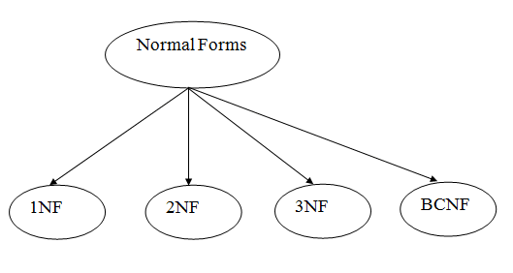

Figure 4.4: Normalization

Source: <https://www.javatpoint.com/dbms-normalization>, viewed on 10, March, 2021

**First Normal Form (1NF)**

A relation will be 1NF if it contains an atomic value. It states that an attribute of a table cannot hold multiple values. It must hold only single-valued attribute. First normal form disallows the multi-valued attribute, composite attribute, and their combinations.

**Example:** Relation CUSTOMER is not in 1NF because of multi-valued attribute EMP_PHONE.

**CUSTOMER table**

|  |  |  |  |
| --- | --- | --- | --- |
| **customerID** | **customername** | **customertelephone** | **customerdistrict** |
| 14 | John | 7272826385, 9064738238 | UP |
| 20 | Harry | 8574783832 | Bihar |

Table 4.7: 1st Normal Form A

The decomposition of the CUSTOMER table into 1NF has been shown below

|  |  |  |  |
| --- | --- | --- | --- |
| **customerID** | **customername** | **customertelephone** | **customerdistrict** |
| 14 | John | 7272826385 | UP |
| 14 | John | 9064738238 | UP |
| 20 | Harry | 8574783832 | Bihar |

Table 4.8: 1st Normal Form B

**Second Normal Form (2NF)**

In the 2NF, relational must be in 1NF.In the second normal form, all non-key attributes are fully functional dependent on the primary key

**Example:** Let's assume, a school can store the data of FARMERs and the subjects they teach. In a school, a FARMER can teach more than one subject.

**FARMER table**

|  |  |  |
| --- | --- | --- |
| **farmerID** | **Farmername** | **idnumber** |
| 25 | John | 1985676565456 |
| 25 | John | 1986676565456 |
| 47 | Harry | 1987676565456 |
| 83 | Henry | 1988676565456 |

Table 4.9: 2nd Normal Form A

In the given table, non-prime attribute idnumber is dependent on farmerID which is a proper subset of a candidate key. That's why it violates the rule for 2NF.

To convert the given table into 2NF, we decompose it into two tables:

**FARMER_DETAIL table:**

|  |  |
| --- | --- |
| **farmerID** | **Idnumber** |
| 25 | 1985676565456 |
| 47 | 1986676565456 |
| 83 | 1987676565456 |

****Table 4.10: 2nd Normal Form B****

**FARMER_ORDER table:**

|  |  |
| --- | --- |
| **FARMER_ID** | **Farmername** |
| 25 | Kim |
| 25 | Yun |
| 47 | Hin |
| 83 | Hwan |
| 83 | Hwang |

Table 4.11: 2nd Normal Form C

**Third Normal Form (3NF)**

A relation will be in 3NF if it is in 2NF and not contain any transitive partial dependency. 3NF is used to reduce the data duplication. It is also used to achieve the data integrity. If there is no transitive dependency for non-prime attributes, then the relation must be in third normal form. A relation is in third normal form if it holds at least one of the following conditions for every non-trivial function dependency X → Y.

1. X is a super key.
2. Y is a prime attribute, i.e., each element of Y is part of some candidate key.

**Example:**

**CUSTOMER_DETAIL table:**

|  |  |  |  |  |
| --- | --- | --- | --- | --- |
| **farmerID** | **farmername** | **Farmertelephone** | **farmerdistrict** | **Farmersector** |
| 222 | Harry | 0783201010 | Nyagatare | Matimba |
| 333 | Stephan | 078302228 | Nyagatare | Musheri |
| 444 | Lan | 078360007 | Nyagatare | Kabale |
| 555 | Katharine | 078306389 | Kayonza | Gahini |
| 666 | John | 0783462007 | Rwamagana | Nyagasambu |

**Table 4.12: 3rd Normal Form A**

**Super key in the table above:**

{farmerID}, {farmerID, farmername}, {farmerID, farmername, farmertelephone}....so on

**Candidate key:** {farmerID}

**FARMER table:**

|  |  |  |
| --- | --- | --- |
| **famerID** | **Farmername** | **farmertelephone** |
| 222 | Harry | 0782201010 |
| 333 | Stephan | 078202228 |
| 444 | Lan | 078260007 |
| 555 | Katharine | 078206389 |
| 666 | John | 0782462007 |

**Table 4.13: 3rd Normal Form B**

**farmeraddress table:**

|  |  |  |
| --- | --- | --- |
| **Farmertelephone** | **Farmerdistrict** | **farmersector** |
| 0783201010 | Nyagatare | Matimba |
| 078302228 | Nyagatare | Musheri |
| 078360007 | Nyagatare | Kabale |
| 078306389 | Kayonza | Gahini |
| 0783462007 | Rwamagana | Nyagasambu |

Table 4.14: 3rd Normal Form C

## 4.8.4 Data Dictionary

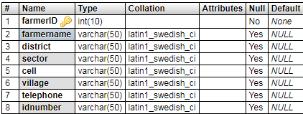

Table 4.15: farmer table

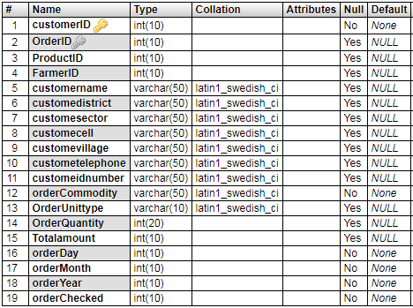

Table 4.16: customer table

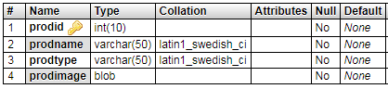

Table 4.17: admin table

## 4.8.5 Entity Relationship Diagram

ERD were used to help in the design and conceptualization of the new system. The Entity Relationship Diagram will be used in data modeling to set up an entity relational model of the system. This involved determining the relationships between the various entities in the system and associating these entities with their attributes and attribute domains.

**Admin**

Views

[**farmerupload**](http://localhost/phpmyadmin/sql.php?db=agric&goto=db_structure.php&table=farmerupload&pos=0)

**farmer**

Uploads

Product

**Customer**

Makes

Orders

Figure 4.5: Entity Relationship Diagram

# 4.9 Architecture design of the new System

We applied 3-tier architecture in the development of our web application due to reliability, re-usability, flexibility and security. Making change in one layer has no efficient on other layers, so, less work is required for maintenance and error correction.

3-tier architecture comprises of Presentation/Client Tier, Middle Tier, and Data Tier

**Presentation/Client Tier**

This layer is on the top of application development hierarchy which enables a client to put some requests by putting a URL in the web browser or enter some data into a form. This layer fetches the results according to the request from the other tiers by communicating with them and presents it to the user.

**Middle Tier**

The layer that works as an agent between the data storage and presentation tier is known as middle tier. This layer also performs logical processing of the application and provides all the functions. In web applications, the middle tier consists of a web server which is responsible to get the request from client tier. It then sends it to data tier after doing appropriate processing on the request generated by the presentation tier, giving back results to the client tier.

**Data Tier**

In 3-tier architecture database server is considered as a third layer of the architecture.

At this level data is stored and retrieved according to the requirements and requests sent by the presentation tier through middle tier. This layer is independent of other tiers due to which the performance and scalability of the system increases.

**User interface**

**Web server**

**Data base**

Figure 4.6: Three Tier Architecture

# CHAPTER FIVE: IMPLEMENTATION, CODING AND TESTING

# 5.1 Implementation and coding

## 5.1.1 Introduction

Systems implementation was done defining how the information system should be built, ensuring that the information system is operational and used and meets quality standard. Systems design. Implementation included Conceptual design – what the system should do, Logical design – what the system should look to the user and Physical design – how the system should be built.

Coding involves designing and writing computer programs that allow the computer hardware to interface with the programmer and the user, leading to the effective execution of application software on the computer system

## 5.1.2 Description of implementation Tools and technology

The researcher used two main categories of coding, scripting and programming for creating Web Application as described below.

**Client Side Coding**

Client Side Scripting is the type of code that is executed or interpreted by browsers. Client Side Scripting is generally viewable by any visitor to a site. Below are some common Client Side Scripting technologies used to develop the application.

1. HTML (HyperText Markup Language)
2. CSS (Cascading Style Sheets)
3. JavaScript
4. Ajax (Asynchronous JavaScript and XML)
5. Bootstrap

**Server Side Scripting / Coding**

Server Side Scripting is the type of code that is executed or interpreted by the web server. Server Side Scripting is not viewable or accessible by any visitor or general public. Below are the common Server Side Scripting technologies:

1. PHP (very common Server Side Scripting language - Windows based Open Source - free redistribution, usually combines with MySQL database)
2. Zend Framework (PHP's Object Oriented Web Application Framework)
3. MySQL database Management System. It is a DBMS enclosed in Wamp Server that the programmer used to create, define, Manage and access MySQL Database.

**Program Libraries**

Program libraries are a collection of commonly used functions, classes or subroutines which provide ease of development and maintenance by allowing developers to easily add or edit functionalities to a frame worked or modular type application.

**Web Application Frameworks**

Web Application Frameworks are sets of program libraries, components and tools organized in an architecture system allowing developers to build and maintain complex web application projects using a fast and efficient approach. Web Application Frameworks are designed to streamline programming and promote code reuse by setting forth folder organization and structure, documentation, guidelines and libraries (reusable codes for common functions and classes).

## 5.1.3Screen Shots and Source Codes

**Home Page**

This is the first page of the system that allows the user to access all initial controls like products, log in and contact and about us controls

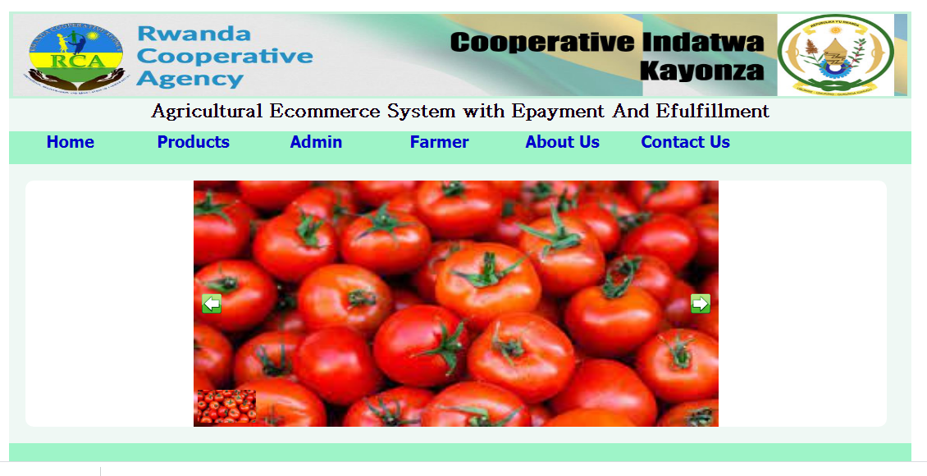

Figure 5.1: Home Page

**Home Page Source Code**

<?php require "header.php"; ?>

<div id="top">

<h1>Agricultural Ecommerce System with Epayment And Efulfillment</h1>

</div>

<div id="seperator">

</div>

<div id="nav">

<nav>

<ul>

<li><a href="farmer/welcome.php">Register</a></li>

<li><a href="admin/">Admin</a></li>

<li><a href="farmer/login.php">Add Product</a></li>

</ul>

</nav>

</div>

<div id="middle">

<?php

$result = $con ->query("SELECT * FROM product p RIGHT JOIN farmerupload fu ON(p.prodid=fu.productID)");

if ($result ->num_rows ==0) {

echo "";

}else{

while ($row = $result ->fetch_object()) {

$uploadID = $row ->uploadID;

$productID = $row ->productID;

$farmerID = $row ->farmerID;

$unittype = $row ->unittype;

$quantity = $row ->quantity;

$priceperunit = $row ->priceperunit;

$product = $row ->prodname;

?>

<div id="productimage">

<img src="img/<?php echo substr($row ->prodimage,0); ?>">

</div>

<div id="productdata">

<table border="0" cellpadding="0" cellspacing="0" width="800px" height="130px">

<tr>

<th>Product</th>

<th>Type</th>

<th>Quantity</th>

<th>Unit Price</th>

<th>Upload Date</th>

<th>Action</th>

</tr>

<tr>

<td><?php echo $row ->prodname; ?></td><td><?php echo $row ->prodtype; ?></td>

<td><?php echo $row ->quantity." - ".$row ->unittype; ?></td><td><?php $row ->priceperunit; ?></td>

<td><?php echo $row ->uploadday." - ".$row ->uploadmonth." - ".$row ->uploadyear; ?></td>

<td><a href="<?php echo "customer/?link=0&&orderid=$uploadID&&productID=$productID&&farmerID=$farmerID&&unittype=$unittype&&quantity=$quantity&&priceperunit=$priceperunit&&product=$product"; ?>">Order Now</a></td>

</tr>

</table>

</div>

<?php

}

}

?>

</div>

<?php require "footer.php"; ?>

**Login Page**

This is a page that will allow CIK Super Admin to login and enter the system using assigned authentication details

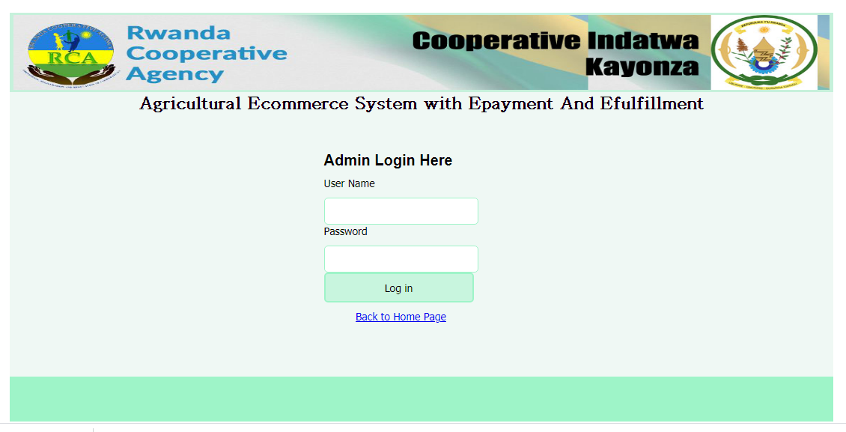

Figure 5.2: Login Page

**Login Page Source Code**

<?php require "../header.php"; ?>

<div id="top">

<h1>Agricultural Ecommerce System with E-payment And E-fulfillment</h1>

</div>

<div id="middle">

<div id="login">

<h3>Admin Login Here</h3>

<form method="post" action="">

<ul>

<li><label>User Name</label></li>

<li><input type="text" name="username"></li>

<li><label>Password</label></li>

<li><input type="password" name="password"></li>

<li><button type="submit" name="log">Log in </button></li>

<li>

<?php

if (isset($_POST["log"])) {

$a = $_POST["username"];

$b = $_POST["password"];

if (empty($a) || empty($b)) {

echo "<cite>Fill all the fields to proceed!</cite>";

}elseif (is_numeric($a)) {

echo "<cite>Please fill text in user name field!</cite>";

}else{

$result = $con ->query("SELECT * FROM admin WHERE adminusername='$a' AND adminpassword='$b'");

if ($result ->num_rows == 1) {

while ($row = $result ->fetch_object()) {

$_SESSION["fullname"]=$row ->adminfullname;

}

header("location:welcome.php");

}else{

echo "<cite>Wrong User Name or Password!</cite>";

}

}

}

?>

</li>

<li><a href="../index.php">Back to Home Page</a></li>

</ul>

</form>

</div>

</div>

<div id="bottom">

</div>

<?php require "../footer.php"; ?>

**Administrators Page**

It is this page where the administrator practices his system services

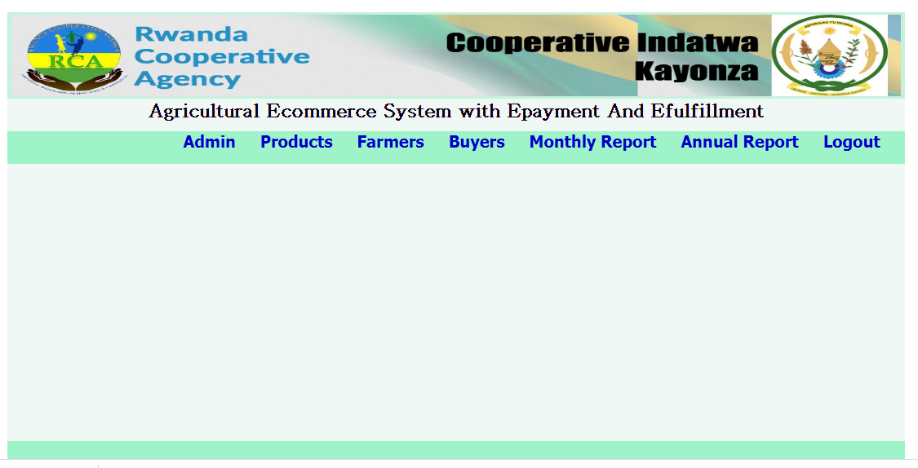

Figure 5.3: Administrator’s Page

**Administrator Page Source Code**

<h3 style="float: left;"><a href="?link=1.1">Add New</a></h3><br><br>

<table border="1" cellpadding="0" cellspacing="0" width="1000px">

<tr>

<th colspan="100%"><h3>List of Administrators</h3></th>

</tr>

<tr>

<th>No</th><th>Full Name</th><th>Username</th><th>Password</th><th>Contact</th><th>Manage</th>

</tr>

<?php

$result = $con ->query("SELECT * FROM admin");

if ($result ->num_rows ==0) {

echo "";

}else{

$x=1;

while ($row = $result ->fetch_object()) {

?>

<tr>

<td><?php echo $x; ?></td>

<td><?php echo $row ->adminfullname; ?></td>

<td><?php echo $row ->adminusername; ?></td>

<td><?php echo $row ->adminpassword; ?></td>

<td><?php echo $row ->adminphone; ?></td>

<td><a href="">Delete</a></td>

</tr>

<?php

$x++;

}

}

?>

</table>

**FarmerPage**

This is the Famers page. It helps him to upload product, View potential Customers and interact with them

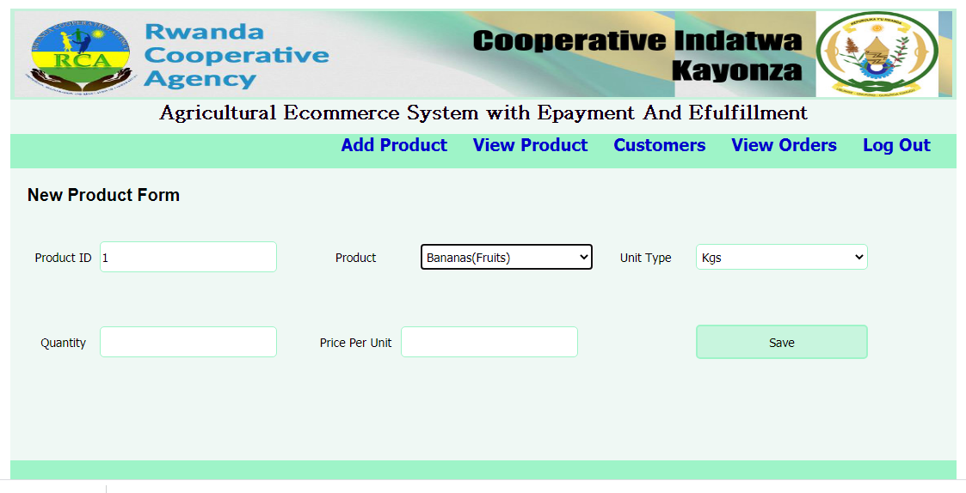

Figure 5.4: Farmers Page

**Farmers Page Source Code**

<?php require "../header.php"; ?>

<div id="top">

<h1>Agricultural Ecommerce System with E-payment And E-fulfillment</h1>

</div>

<div id="navadmin">

<nav>

<ul>

<li><a href="?link=1">Log Out</a></li>

<li><a href="?link=2">Customers</a></li>

<li><a href="?link=0">Products</a></li>

</ul>

</nav>

</div>

<div id="middle">

<?php

$link = $_GET["link"];

if ($link == 1) {

header("location:logout.php");

}elseif(empty($link)){

require "addproduct.php";

}elseif($link == 0.1){

require "addproductform.php";

}

?>

</div>

<div id="bottom">

</div>

<?php require "../footer.php"; ?>

# 5.2 System Testing

Is it possible to invoke each menu function using logical assumptions that if all parts of the system are correct, the goal will be successfully achieved? In adequate testing or non-testing will leads to errors that may appear few months later. That’s why it is very important to always test the new software. The purpose of the system testing is to consider all the likely variations to which it will be suggested and push the systems to limits. The testing process focuses on the logical intervals of the software ensuring that all statements have been tested and on functional interval is conducting tests to uncover errors and ensure that defined input will produce actual results that agree with the required results. Program level testing, modules level testing integrated and carried out.

There are two major type of testing they are

1. White Box Testing.

2. Black Box Testing.

## 5.2.1 White Box Testing

White box sometimes called “Glass box testing” is a test case design that uses the control structure of the procedural design to drive test case. Using white box testing methods, the following tests were made on the system

a) All independent paths within a module have been exercised once. In our system, ensuring that case was selected and executed checked all case structures. The bugs that were prevailing in some part of the code are identified and debugged.

b) All logical decisions were checked for the truth and falsity of the values.

## 5.2.2 Black box Testing

Black box testing focuses on the functional requirements of the software. This is black box testing enables the software engineering to derive a set of input conditions that will fullyexercise all functional requirements for a program. Black box testing is not an alternative to white box testing rather it is complementary approach that is likely to uncover a different class of errors that white box methods like.

1) Interface errors

2) Performance in data structure

3) Performance errors

4) Initializing and termination errors

# 5.3 Recommendations

Our project is meant to satisfy agricultural producers and customer interaction needs. Several user friendly interfaces have also been adopted. This package shall prove to be a powerful in satisfying all the requirements of the users. It is with utmost faith that I present this software to you hoping that it will solve your problems and encourage you to continue appreciating technology because it is meant to change and ease all our work that seems to be very difficult. I don’t mean that my project is the best or that I have used the best technology available it just a simple and a humble venture that is easy to understand. However, I would encourage anyone who has the ability to advance it using advanced technologies so as to increase its capabilities.In extent we can add GPS system in build and can give live chat online option to users. This project can also be extended to IOS Platform and several states. Database can be included. It could also allow local business to push deals/coupons within a certain geographic area.

# 5.4 Conclusion

In conclusion, the software can be used as an inventory system to provide a frame work that enables the farmers to make reasonable transactions made within a limited time frame. Each transaction made on the system go hand in hand with the data being updated in the database in our case it is MySQL Database which is the back end. Last but not least it is not the work that played the ways to success but ALMIGHTY GOD.

# Appendix A: References

1. Manuel Blum, Paul Feldman, and Silvio Micali. Proving security against chosen cyphertext attacks. In S. Goldwasser, editor, Proc. CRYPTO 88, pages 256–268. Springer-Verlag, 1988. Lecture Notes in Computer Science No. 403.
2. Dan Boneh and Matt Franklin. Identity-based encryption from the Weil pairing. In Joe Killian, editor, Proc. CRYPTO 01, pages 213–229, 2001.
3. Stefan Brands. Untraceable off-line cash in wallets with observers (extended abstract). In Douglas R. Stinson, editor, Proc. CRYPTO 93, pages 302–318. Springer, 1994. Lecture Notes in Computer Science No. 773.
4. Stefan A. Brands. Rethinking public key infrastructures and digital certificates – Building in privacy. PhD thesis, Eindhoven Institute of Technology, Eindhoven, The Netherlands, 1999.
5. Guilles Brassard, David Chaum, and Claude Cr´epeau. Minimum disclosure proofs of knowledge. JCSS, 37(2):156–189, 1988.
6. Anna Lysyanskaya. Signature Schemes and Applications to Cryptographic Protocol Design. PhD thesis, Massachusetts Institute of Technology, Cambridge, MA, USA, September 2002.
7. Anna Lysyanskaya, Ronald L. Rivest, Amit Sahai, and Stefan Wolf. Pseudonym systems (extended abstract). In Howard Heys and Carlisle Adams, editors, Selected Areas in Cryptography, pages 184–199. Springer-Verlag, 1999. Lecture Notes in Computer Science No. 1758.
8. Ueli Maurer. Information-theoretic cryptography (extended abstract). Lecture Notes in Computer Science, 1666:47–64, 1999. [120] Alfred J. Menezes, Paul C. van Oorschot, and Scott A. Vanstone. Handbook of Applied Cryptography. CRC Press, 1997.

# Appendix B: Questionnaire

**Questionnaire**

Dir Sir/ Madam,

My name is **…………………………**; I’m a student at UTB in the department of Business Information Technology. I am conducting an academic research entitled, **“**Commercial room renting and contract management System. A Case Study: Cooperative Indatwa Kayonza.” For the purpose of achieving my research objectives, I would request that you help me to fill the attached research questionnaire. The data (information) collected through this questionnaire will be kept confidential and will be used exclusively for research purpose. I am asking you to respond willingly and honestly to all questions

**Instructions:** Please, respond to all questions by ticking ( ) on the number or all that corresponds to your opinion or filling where needed.

**SECTION A: Identification of respondent**

1. Gender of respondents

Male

Female

2. Age of respondents

Less than 20 years’ old

21-30 years old

31-40 years old

41-50 years old

3. Education level

Secondary level

Bachelor’s Degree

Masters and above

PHD

Others

SECTION B: Questions

*1. How does the CIK Inter Communicate with Clients?*

|  |  |
| --- | --- |
| **Answer** | **Tick** |
| Face to Face |  |
| Telephone |  |
| Others (specify) |  |

*2. Do you have a computerized system in CIK?*

|  |  |
| --- | --- |
| **Answer** | **Tick** |
| Yes |  |
| No |  |

*3. What is your satisfaction level on the current system?*

|  |  |
| --- | --- |
| **Answer** | **Tick** |
| Highly satisfied |  |
| Satisfied |  |
| Neutral |  |
| Unsatisfied |  |

*4. Do you wish there could be an Agricultural Ecommerce System with E-payment and E-fulfillment?*

|  |  |
| --- | --- |
| **Answer** | **Tick** |
| Strongly agree |  |
| agree |  |
| neutral |  |
| disagree |  |
| Strongly disagree |  |

***Thank you for your cooperation***